Project Design Phase-II
Technology Stack (Architecture & Stack)

Date | 31 January 3035
Team ID | LTVIP2026TMIDS82222
Project Name | HouseHunt – Finding Your Perfect Rental Home
Maximum Marks | 4 Marks

Technical Architecture
Architecture Overview
1️⃣ Presentation Layer (Frontend)
- Built using React
- Provides UI for Renter, Owner, Admin
- Communicates with backend using REST APIs via Axios
2️⃣ Application Layer (Backend)
- Built using Node.js and Express.js
- Handles business logic
- Manages authentication using JWT
- Processes booking, property CRUD, approval system
3️⃣ Data Layer (Database)
- MongoDB (NoSQL database)
- Stores Users, Properties, Bookings collections

Architecture Flow
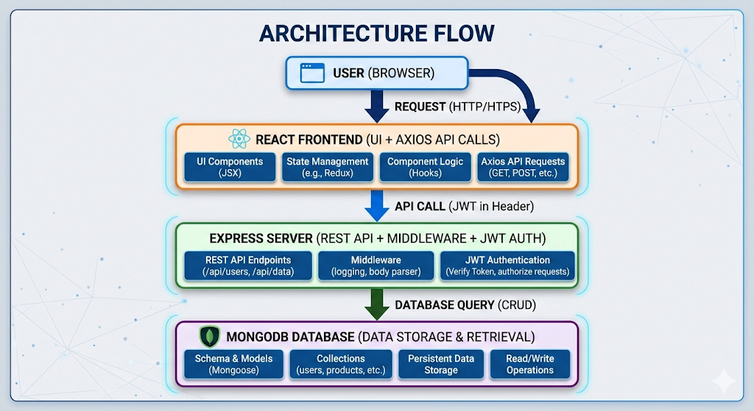

Table-1 : Components & Technologies:
S.No | Component | Description | Technology
1 | User Interface | Web-based user interaction for Renter, Owner & Admin dashboards | HTML, CSS, JavaScript, React.js, Bootstrap, Ant Design
2 | Application Logic-1 | User Authentication & Role Management | Node.js, Express.js, JWT
3 | Application Logic-2 | Property Management (CRUD operations) | Express.js, Mongoose
4 | Application Logic-3 | Booking Management & Status Tracking | Node.js, Express.js
5 | Database | Stores Users, Properties, Bookings (NoSQL) | MongoDB
6 | Cloud Database | Optional cloud hosting for production | MongoDB Atlas
7 | File Storage | Property Image Storage | Local File System / Multer
8 | External API-1 | HTTP Requests from frontend to backend | Axios
9 | External API-2 | Date & Time Handling | Moment.js
10 | Machine Learning Model | (Future Scope – Recommendation System) | AI Recommendation Model (Planned)
11 | Infrastructure (Server / Cloud) | Application Deployment | Localhost (Development), Render/Heroku (Cloud Deployment Option)

Table-2: Application Characteristics:

S.No | Characteristics | Description | Technology
1 | Open-Source Frameworks | Uses open-source technologies for development | React.js, Node.js, Express.js, MongoDB
2 | Security Implementations | Password encryption, JWT authentication, role-based access | bcryptjs, JWT, Middleware Authorization
3 | Scalable Architecture | 3-Tier Architecture (Frontend, Backend, Database) | MERN Stack
4 | Availability | Application accessible 24/7 via web browser | Cloud Deployment (MongoDB Atlas + Hosting Platform)
5 | Performance | Fast API responses, optimized queries, lightweight frontend | Express.js, MongoDB Indexing
6 | Maintainability | Modular MVC structure | Controllers, Routes, Models separation
7 | Reliability | Proper error handling & validation | Express Middleware & Mongoose Validation

References:
https://react.dev/docs
https://nodejs.org/en/docs/

